EVAL 3 - Predevelopment

ECET 3220 Summer 2008

Tyler Long
Wil Smith II
Vincent Watkins

Table of Contents
1. Board Layout Diagram 1
2. Parts List 3

- Board Layout Diagram

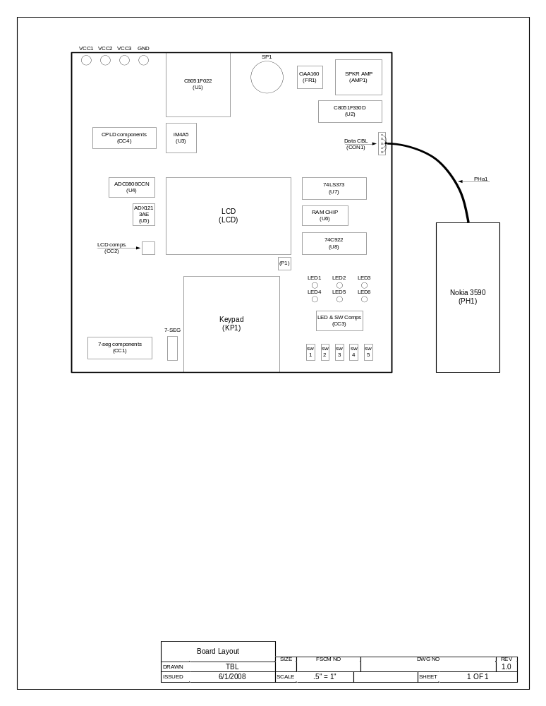
- Parts List

